MODULE-4

Nanomaterials and Display Systems
NanoMaterials

Definition:
Nano materials can be defined as those materials, whose characteristic length scale lies within the nano range (1-100 nm). OR
A nano materials refers to a materials with at least one of its dimension is in nanoscale (10⁻⁹m).

Size dependent properties of Nanomaterials

- Surface Area:-If a bulk material is subdivided into individual nano materials, the total surface area greatly increased. This will make materials more chemically reactive, in some cases materials that are inert in bulk form are more reactive when converted into nano scale and affect their properties like Catalytic activity, gas adsorption chemical reactivity significantly.
Ex. Bulk gold is catalytically inactive. But Gold nano particles are catalytically very active for selective redox reaction.

2. Catalytic Properties:
- In chemistry, a catalytic substance or a substance with catalytic properties which increases the speed of a chemical reaction.
- Nanomaterial-based catalysts are usually heterogeneous catalysts broken up into metal nanoparticles in order to enhance the catalytic process. Metal nanoparticles have high surface area, which can increase catalytic activity. Nanoparticle catalysts can be easily separated and recycled.
3. Conducting properties:-
- The electronic bands in bulk materials are continuous due to overlapping of orbitals of billions of atoms. But, in the nano size materials, very few atoms or molecules are present so the electronics bands become separate. And the separation between different electronic state varies with size of nano materials.
- Hence, some metals which are good conductors in bulk become semiconductors and insulators as their size is decreased to nano scale.
Preparation of Nano materials

SOL-GEL Method

In sol-gel synthesis, either a metal salt or metal alkoxide such as Tetra Ethyl Ortho Silicate Si(OEt)₄ is used as precursor
First Sol is prepared by dispersing precursors in solvent ( in alcohol or water ) in acidic or basic conditions.

MOR + H₂O MOH + ROH (Hydrolysis)
Metal Alkoxide. Metal Hydroxide

Conversion of sol into gel: Sol is further converted into gel by poly condensation results in the formation of oxide bridged network is called gel.

MOH + MOR M-O-M + R-OH (Condensation)

- Aging of the gel: Gel on aging for a known period of time, finally condenses to to nanoscale clusters of metal hydroxides.
- Drying of gel; If the solvent is isolated by thermal evoparation, resulting product is termed as Xerogel. If the solvent is extracted under super critical conditions, the product is an Aerogel.
- Calcination; The sample thus obtained is heat treated at higher temperature (>800⁰C) to obtain nano particles.
Advantages
- Nano materials of high purity with good homogeneity can be obtained
- Easy to control the size and shape of nano materials
- Simple and inexpensive equipment
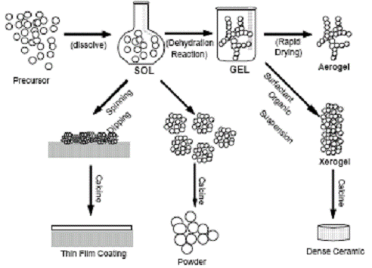

Co-Precipitation Method

Step 1:- In this techniques the precursors ( inorganic metal salts such as nitrates, chlorides or acetates ) is dissolved in water.
Step 2:- metal cations exists in the form of hydrated species, for example [Fe(H₂O)₆]³⁺, [Al(H₂O)₆]³⁺etc.
Step 3:- The metal hydrated species is added to the precipitating agent like NaOH or NH₄OH, it causes condensation of metal hydrated species
Step 4:- Thus concentration of solution increases and reaches a critical level called super saturation. At this concentration nucleation formation is initiated. Thus nucleus further grows into particles, which gets precipitated.
Step 5:- The precipitate is filtrated, washed with water and finally calcined at high temperature to get crystalline metal oxide.

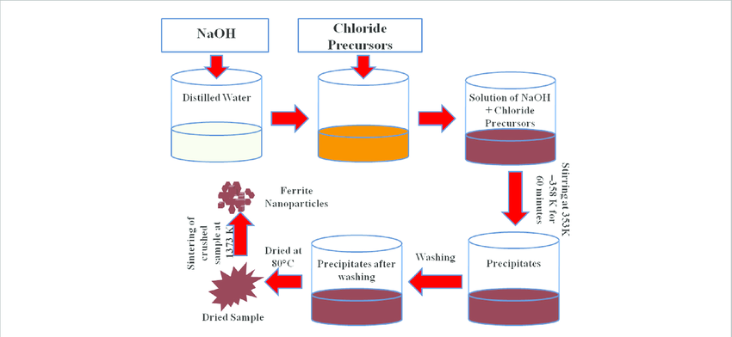
Properties and Applications of Nanomaterials
Nanofibers:

Nanofibers are the Nanomaterials that have fiber-like shape having diameter in nanoscale.(1-100 nm)

Properties

- Have excellent mechanical properties
- They have satisfactory biodegradability
- Provide higher surface area
- They have roughness and abrasion resistance
- They have light in weight
Applications
- Carbon nanofibers are used as gas sensors to detect H₂S, NH₃, NO, CO, CH₄, H₂ and Ethanol
- Used in electrical and thermal conducting applications
- Used in drug delivery applications
- Used in cosmetic skin masks
- Used as protective clothing in military

Nanophotonics
Nanophotonics or nano-optics is a part of nanotechnology that investigates the behaviour of light on nanometre scales as well as interactions of nanometer sized objects with light. Nanophotonics is also considered a branch of electrical engineering, optics, and optical engineering—as well as being a branch of nanotechnology.
Properties
In nanophotonics, material is structured at the nanoscale, in order to create new optical properties for a large variety of applications.
They have Photoluminescence.
They have strongly localized radiation sources.
They have vast spectrum of plane waves with different wave numbers.
Small detectors tend to have variety of properties like low noise, high speed and low voltage and power.

Applications
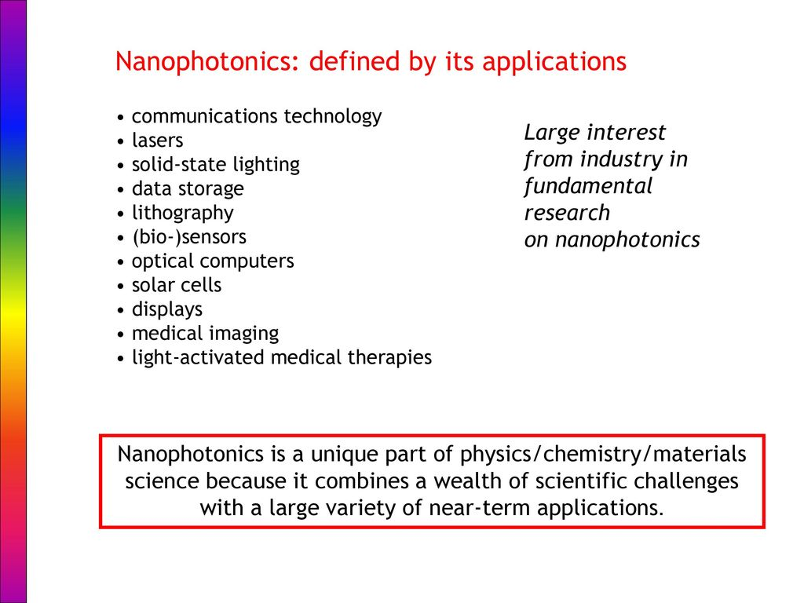

Nanosensors
Nanosensors are chemical or mechanical sensors that can be used to detect the presence of chemical species and nanoparticles, or monitor physical parameters such as temperature, on the nanoscale.
Properties
- Optical nanosensors measures change in light intensity
- Electrochemical nanosensors measures change in electric distribution
- Piezoelectric nanosensors measures change in mass
- Calorimetric nanosensors measures change in heat

Applications
- To detect various chemicals in gases for pollution monitoring
- Used to measure the soil pH, nutrients, residual particles, temperature, and moisture content.
- For medical diagnostic purposes
Display Systems
Display Systems are used to share information in a digital format. These systems can consist of a single display with a digital signage player, multiple displays with digital signage players across a campus or facility or a video wall with a video processor.

Liquid Crystals (LC’s)
Liquid crystals are a unique state of matter between solid (crystalline) and liquid (isotropic) phases. An ordered fluid mesophase of an organic long-chain molecules possessing both solid like molecular order and liquid-like character is known as a liquid Crystal.

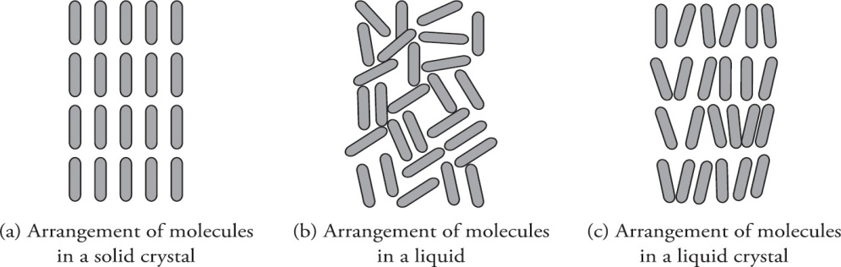
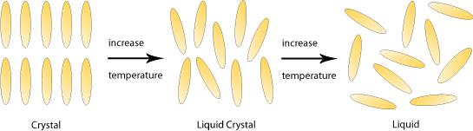

Classification of Liquid Crystals
Liquid crystals can be classified as:
    - Thermotropic liquid crystals
    - Lyotropic liquid crystals

Thermotropic liquid crystals
When long-chain organic solids are heated, they undergo sharp phase transitions at particular temperatures yielding liquid crystals.
The phase transition involving these intermediate phases are mostly naturally affected by the changing temperature and hence, they are thermotropic liquid crystals.

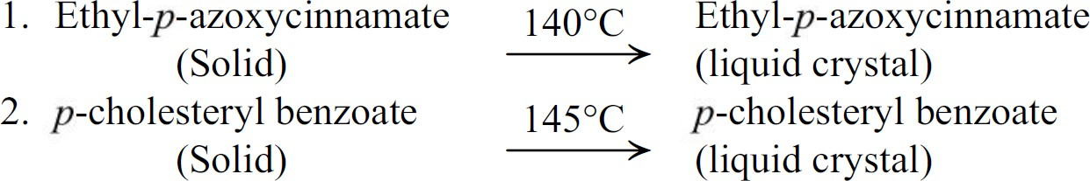

Lyotropic liquid crystals

Lyotropic liquid crystals are formed in mixtures of amphiphiles (e.g., surfactants) and solvents, for example, detergents and water. Consequently, these phases are thermodynamically stable at defined temperatures, pressures, and concentrations.
Cell membranes and cell walls are examples of lyotropic liquid crystals. Phospholipid
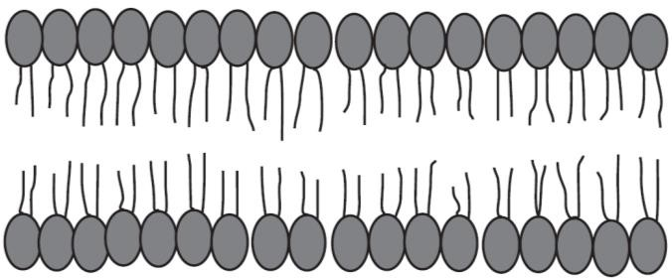
molecules are arranged perpendicular to the membrane surface. Soaps and detergents form lyotropic crystals when they combine with water.

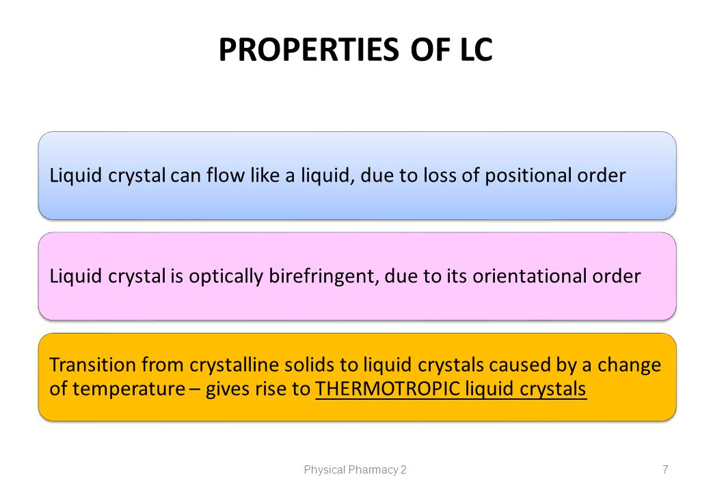
Applications in Liquid Crystal Displays (LCD’s)
- Used in digital wrist watch
- Display images in digital cameras
- Used in numerical counters
- Display screen in calculators
- Mainly used in television
- Used in mobile screens
- Used in video players
- Used in image sensing circuits
Organic Light Emitting Diodes (OLED’s)
An organic light-emitting diode, also known as organic electroluminescent diode, is a light-emitting diode in which the emissive electroluminescent layer is a film of organic compound that emits light in response to an electric current.

Properties:
- Very thin solid-state device.
- Light in weight
- Colour tuning for full colour displays
- They have high Flexibility
- Low power consumption
Applications:
- To build digital displays in TV screens, cell phones, monitors, car radios, digital cameras.
- It is used in watches. Fossil and Diesel used OLED displays.
- Samsung electronics generated full-colour AMOLED displays on the basis of a white emitter.

Quantum Dot Light-Emitting Diode (QLED):
Quantum dot light-emitting diodes (QLEDs) are a class of high-performance solution-processed electroluminescent (EL) devices highly attractive for next-generation display applications.


Properties:
- High color saturation,
- Tunable color emission, and
- High stability.
Applications:
- For photomedical applications: facilitate widespread clinical applications of photodynamic therapy (PDT) or photobiomodulation (PBM).
- QLED-based photomedical approach could increase cell metabolism over control systems for PBM and
- Kill cancerous cells efficiently for PDT.
Perovskite Materials
Perovskite materials are materials resembling CaTiO₃ (ABX3) which are low cost energy materials used in various optoelectric and photonic devices.

Properties and Applications in Optoelectronic Devices
Properties:
- High Absorption coefficient
- Long range charge transport
- High ion conductivity
- High luminous efficiency
Applications:
- Used for the preparation of Solid oxide fuel cell
- Used as sensor to sense hydrogen
- Used as Piezo electric transduser or themister
- Used as catalyst, thin film resistor, laser super conductor, magnetic memory, ferromagnets

MOST REPEATED QUESTIONS IN VTU EXAM

- What are nanomaterials? Explain the size dependent properties of nanomaterials (8 Marks)
- Describe the synthesis of nanomaterials by Solo-gel method. (7 Marks)
- What are Liquid crystals? Explain the classification, properties and application of liquid crystals in display systems. (7 Marks)
- Mention the Properties and applications of nanofibers, nanophotonics and nano sensors (8 Marks)
- Mention the Properties and applications of : OLED and QLED (6 Marks)
- What are Perovskite materials? Mention the Properties and applications of Perovskite materials. (7Marks)
- Describe the synthesis of nanomaterials by Co- precipitation method (6 Marks)

***********************************************

